Walsh matrix

Intro

It is a square matrix that satisfies:

All elements are either –1 or 1.

Its rows are orthogonal.

Its columns are orthogonal.

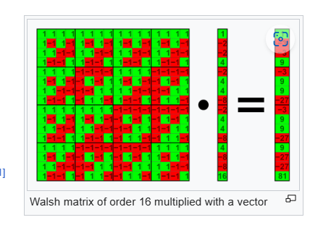

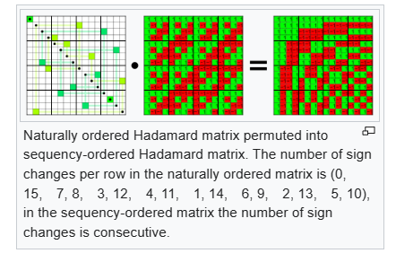

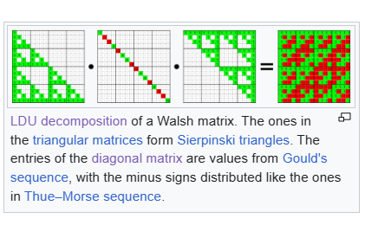

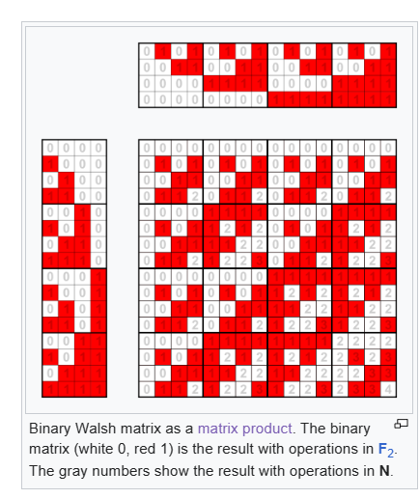

Def

Property

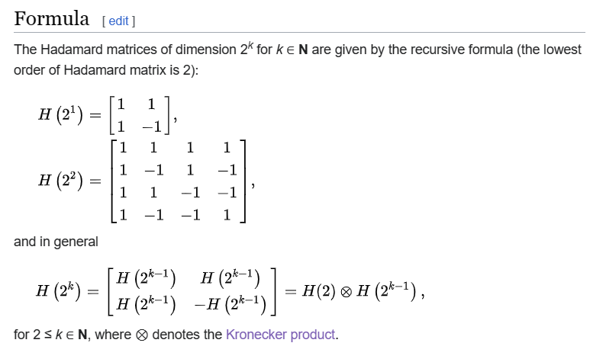

Ref

[Walsh matrix - Wikipedia](https://en.wikipedia.org/wiki/Walsh_matrix)